EXERCISE 4

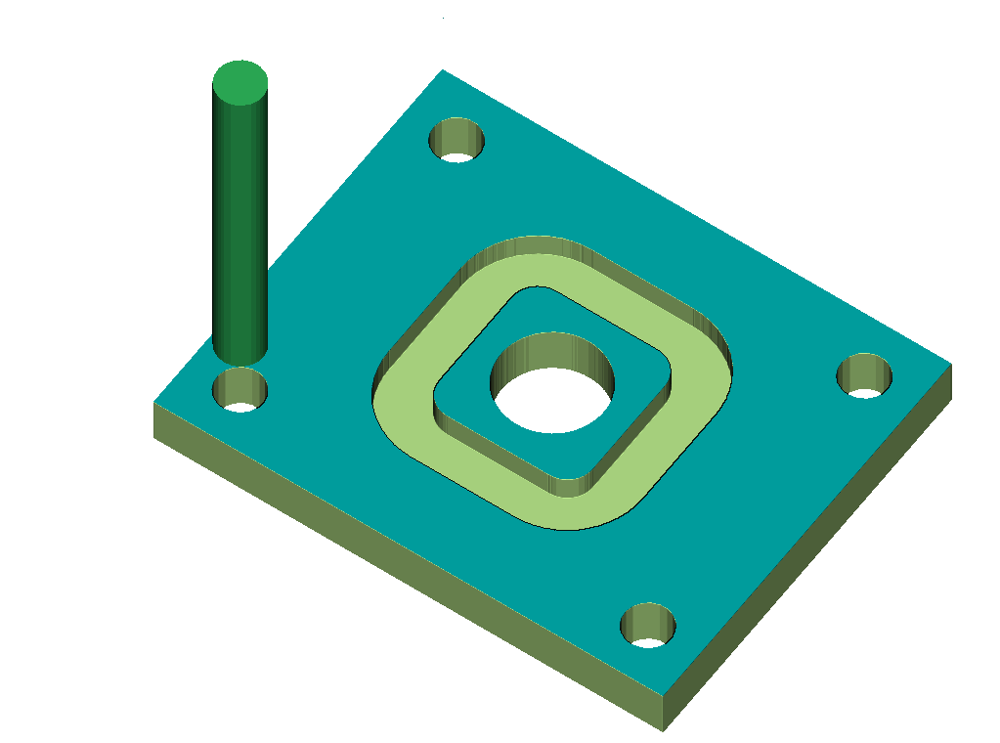

NAME:-
USN :-
SIGN:-

